Battle of the Burgh Fortnite Rules (Duos)
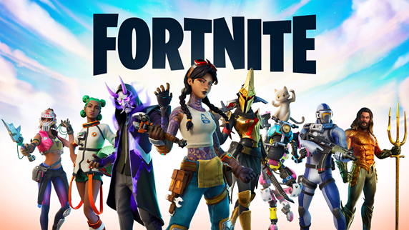
Time and Date: Saturday, September 12, 2020
Mode: Duos
- Kill Race
- Level- 200 Account Required (*Not Battle Pass)
- Must have a minimum of 50 games played on all accounts.
  - Absolutely no smurf accounts!
Requirements:
- “Crossplay” Must Be Enabled
- Team Leader Must Send over Epic Names
- Team Leader Must have a Twitch Account (https://www.twitch.tv/signup) or YouTube Account
- Team Leader Must Stream in “Archive Mode”
- Team Leader Must Provide Screenshots of Players Levels (via Text or DM)
- Team Leader must confirm “if” semi or pro players are on the Team. We have to be aware of all Player Status.
Game Play:
- Battle Of The Burgh Moderators will join on Twitch to monitor each team’s playtime. (Must Stream In “Archive mode”)
- Each Team will play up to an 2-hour (max) of playing time.
- Each screenshot (Three) will have a bonus point system below add to the screenshot elimination count:
  - Victory Royale: 15 Points
  - 2nd: 12 Points
  - 3rd - 4th: 9 PointsBs
  - 5th - 6th: 6 Points
  - 7th - 8th: 3 Points
    - Each Elimination/Kill: 1 Point
Screenshot Requirements:
- Team Leader must submit the final screenshot with the required “Icon Badge” Battle of The Burgh assigns
- Battle of The Burgh will assign the required “Icon” 5 minutes before GamePlay
  - *The objective is to send the best Three (3) screenshots within the 2-hour time slot of your “team's best game with the most kills” to win the tournament.
  - Screenshots must be sent to the Battle of the burgh within fifteen (15) minutes after the 2-hour time limit is completed.
  - Examples:
    - 10am-12pm (Screenshot Required Report Time 12:15 pm)
    - 1pm-3pm (Screenshot Required Report Time 3:15 pm)
    - 4pm-6pm (Screenshot Required Report Time 6:15 pm)
    - 8pm-10pm (Screenshot Required Report Time 10:15 pm)
    - 10pm-12 am (Screenshot Required Report Time 12:15 am)

- No screenshot will be accepted, and Team will be automatically disqualified from the Tournament if:
  - Screenshot are not received within the fifteen (15) minutes grace period
  - Screenshot will not be accepted if the required Icon Badge is not presented.
  - Screenshots will not be accepted if the associated Epic Names for the Team are not presented.
  - Screenshot will not be accepted if it appears manipulated or photoshopped.
    - *We expect professionalism from our gamers.

- In the event of a tiebreaker, damage will be the next determining factor. There will be only one (1) Team crowned the winner.
- FYI Twitch and Youtube Account Links Will Be Provided On Our Social Media Pages (Facebook, Instagram And Twitter)
Tournament Payout Information:
- There is a 24 hour review period to protect all gamers if unfair game play is presented.
- We will release the winners and funds Sunday September 13th, 2020.
*Any Questions or concerns please contact us: 412.385.7091 text or call

